**PROJECT ON SALES INSIGHT OF ATLIQ COMPANY**

**Bhavin Patel is the CEO of ATLIQ Company.**

**AIMS GRID:** It is a central tool for planning any venture and must have for project leaders.This tool helps you to collect the most important information about your project on one simple page and hence lay the foundation for a successful implementation.

**Purpose -** To unlock sales insights that are not visible before for sales team for decision support and automate them to reduced manual time spent in data gathering.

**Stakeholders** - They are available within the company.

1. Sales Director
2. Marketing Team
3. Customer Service Team
4. Data & Analytics Team
5. IT

**End Results -** An automated Dashboard providing Quick & latest sales insights in order to support data driven decision making.

**Success Criteria** -

* Dashboard uncovering Sales order insights with latest data available.
* Sales team able to make better decision & prove 10% cost savings of total spend.
* Sales Analysts stops data gathering manually in order to Save 20% of their business time and reinvest it vales added activity.

Now, the sales director will call the data analyst team and will start discussing that how can we solve this problem. He will also call the IT team Falcon (name of the IT team). Falcons is a team of software engineers who owns the sales management system. So the ATLIQ has this sales management system which is just a simple software that is keeping track of all sales number so whenever they sell any computer or any hard disk in any local region this software prints the invoice so it has all the records stored in a MySQL database and this database and this application is owned by this Falcons team.

Data Analyst team is called Data Masters so the data masters will reach out to Falcons and they will ask Falcons that they want to use their SQL Database because this is the database which has all the records that they need for their analysis and they will also integrate MySQL or use MySQL as a source in their tableau or power bi tool and will build dashboards.

**In Power Bi:-**

**Data Cleaning and ETL-**

1. **First ETL/ DATA TRANSFORMATION** - We will first remove the paris and new york from markets table, by clicking on tranform data and then one new tab will open and then select zone which has null vales for paris and new york and then select all except blank, it will remove both the cells from the table.
2. We will now filter those values whose sales_amount is less than or equal to zero.Again click on the small arrow on Sales_amount row and then deselect 0 and -1 values.So it will remove all those cell whose sales_amount is 0 or -1.
3. Now we will convert the USD to INR in currency table to get the total revenue.For this we have to create new column and then normalized the currency where all the sales amount will be converted to INR. So,we will go to add columns and then add conditional columns and then modify.

you can use this formula:

**= Table.AddColumn(#"Filtered Rows", "norm_sales_amount", each if [currency] = "USD" or [currency]="USD#(cr)" then [sales_amount]*75 else [sales_amount]).**

4.

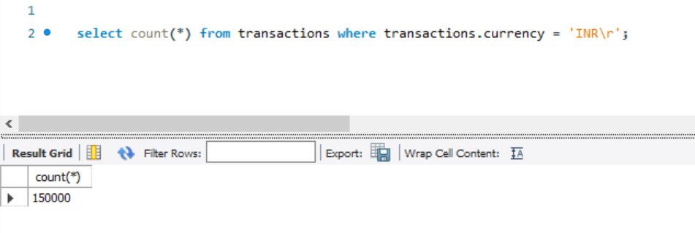

This kind of problem will also occur will cleaning the datasets that duplicate values are there in this datasets so we need to clean this duplicates.

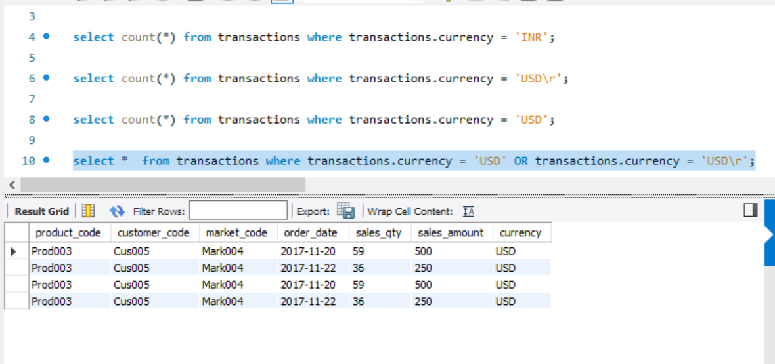

Here,actually there are two values which are duplicates so we need to remove this.

So,we will remove INR values not INR\r values because it is in more quantity.

In transaction table select the current columns and select those 2nd INR AND USD.

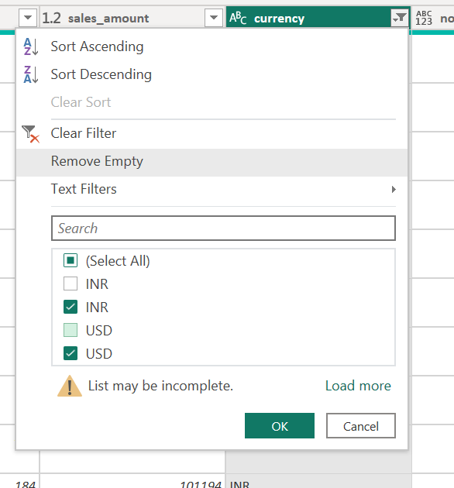 **Or use this formula -:** = Table.SelectRows(#"Added Conditional Column1", each ([currency] = "INR#(cr)" or [currency] = "USD#.

So,by this we have also removed the duplicate values.

**Creating DASHBOARD:-**

1. Select Enter Data , load BaseMeasures. In the right side BaseMeasures will be visible so click on the three dots and select new measures.Then write this two formulas:-

Revenue = SUM('sales transactions'[sales_amount])

Sales qty = SUM('sales transactions'[sales_qty])

In the dropdown of BaseMeasures two options will be showing one is Revenue and other is Sales_qty.

1. Drag Revenue in the canvas and change the visualization to Card.Then change the font to 35.Similarly drag Sales_qty in the canvas and set it to 35.
2. Tracking the data in terms of revenue and sales quantity. Now, CTRL C + ctrl v the revenue and then paste it downwards and change the visualization too to horizontal bar chart.Then,add customer_names in the Y axis field by drag and drop.

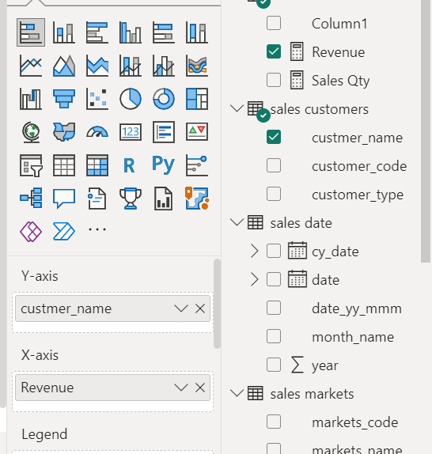

Then remove the title from both X and Y axis. Then add data labels and from display units select millions.Change the title of the data as Revenue by Customer. Copy the revenue data and paste similarly change the tite of the data as Sales by customer.

1. Now we will track the revenue in terms of year.Drag and drop year in the canvas.Then select slicer as visualization tool and from slicer setting choose vertical list.
2. Then we will count the top 5 customers and top 5 products , we will copy the revenue by markets data and for products we will copy the top 5 customers and then we will change the visualization and filters on this visual accordingly to the photo.Then we will change the title and color of the data.We can increase the y axis max size to 43 so that the name of the customers and products is clearly visible.

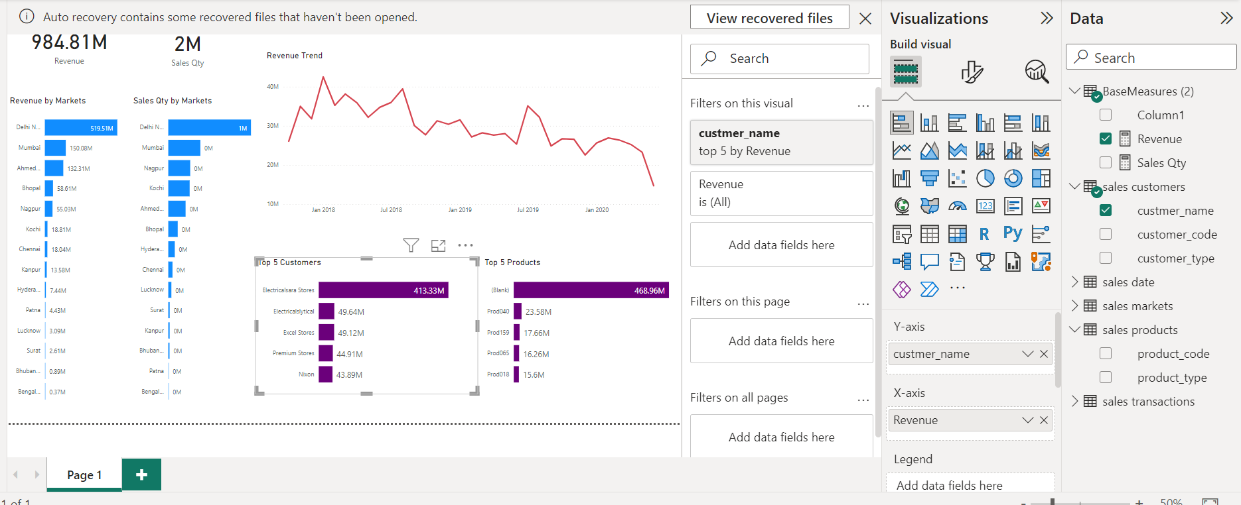

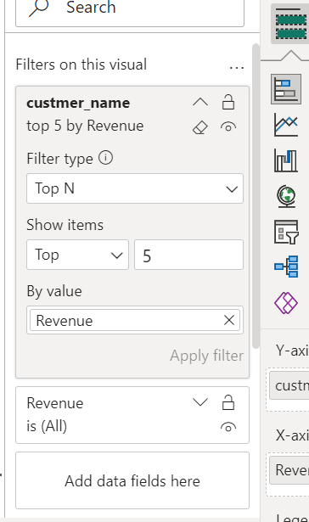

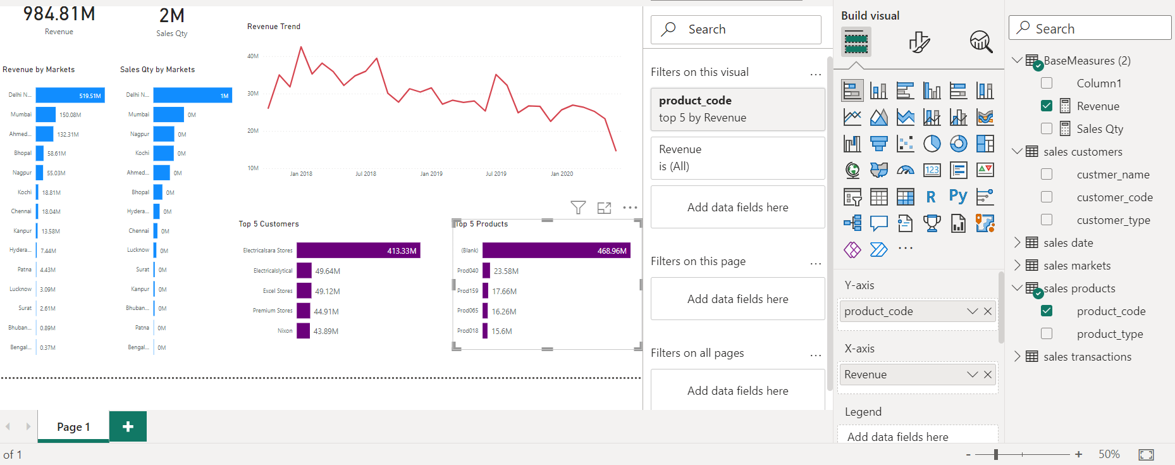

1. Then drag and drop revenue on the canvas and then select line chart as visualization graph.Then add the x axis.Then change the title to Revenue trend.For x and y axis remove the data label or title.Then we can also change the color accordingly.

